EXERCISE 8.1

Question 1:

In ∆ABC right angled at B, AB = 24 cm, BC = 7 cm. Determine:  
(i) sin A, cos A  
(ii) sin C, cos C

Solution:

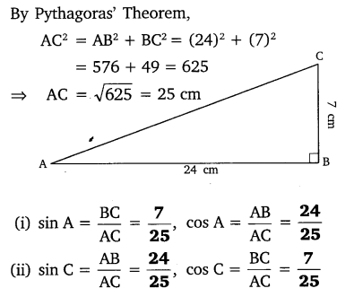

Question 2:

In given figure, find tan P – cot R.

Solution:

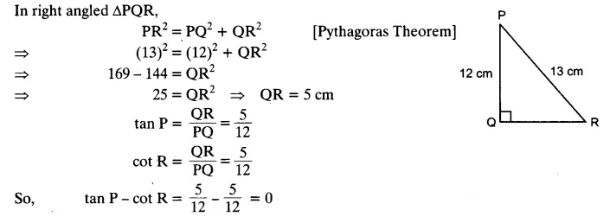

Question 3:

If sin A = 3/4, calculate cos A and tan A.

Solution:

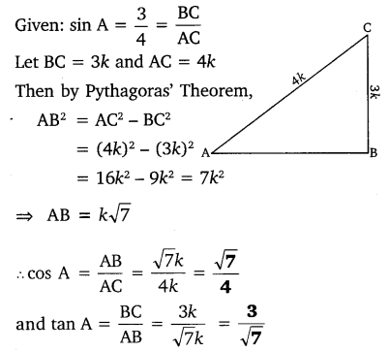

Question 4:

Given 15 cot A = 8, find sin A and sec A.

Solution:

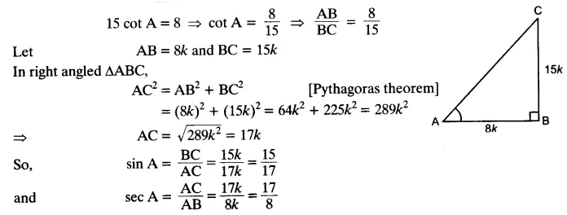

Question 5:

Given sec θ = 13/12 , calculate all other trigonometric ratios.

Solution:

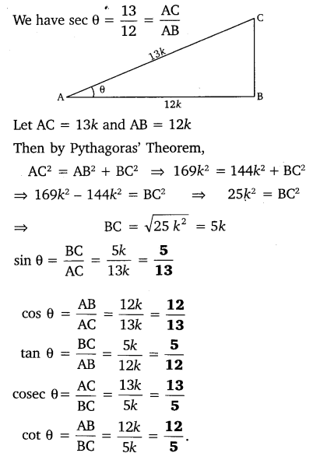

Question 6:

If ∠A and ∠B are acute angles such that cos A = cos B, then show that ∠A = ∠B.

Solution:

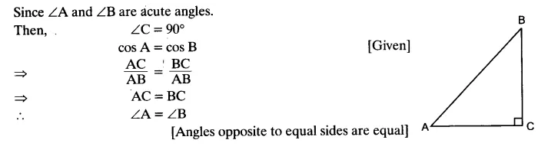

Question 7:

If cot θ = 78, evaluate:  
(i) (1+sinθ)(1−sinθ)/(1+cosθ)(1−cosθ)  
(ii) cot²θ

Solution:

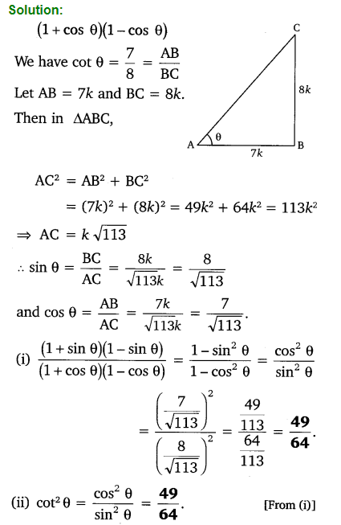

Question 8:

If 3 cot A = 4, check whether 1−tan2A/1+tan2A = cos² A – sin² A or not.

Solution:



Question 9:

In triangle ABC, right angled at B, if tan A = 1/√3, find the value of:  
(i) sin A cos C + cos A sin C  
(ii) cos A cos C – sin A sin C

Solution:

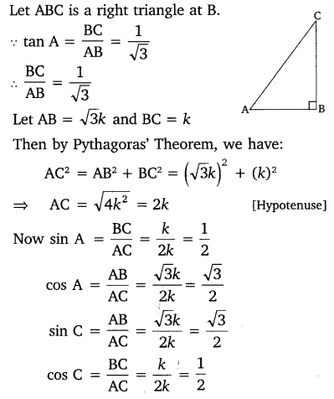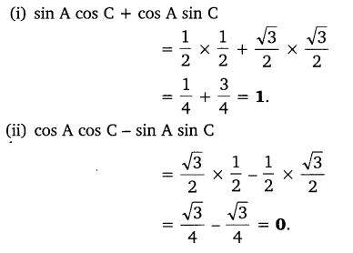

Question 10:

In ΔPQR, right-angled at Q, PR + QR = 25 cm and PQ = 5 cm. Determine the values of sin P, cos P and tan P.

Solution:

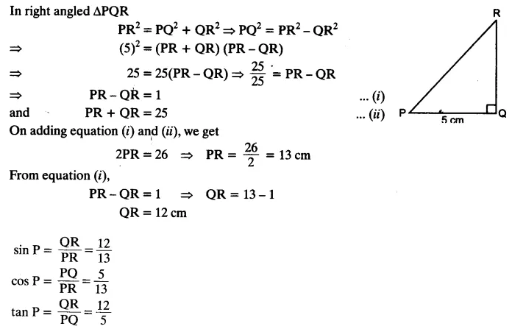

Question 11:

State whether the following statements are true or false. Justify your answer.  
(i) The value of tan A is always less than 1.  
(ii) sec A = 12/5 for some value of angle A.  
(iii) cos A is the abbreviation used for the cosecant of angle A.  
(iv) cot A is the product of cot and A.  
(v) sin θ = 4/3 for some angle.

Solution:

